Executive Summary
The United States grants over 85,000 H-1B visas annually, with thousands more E-3 and H-1B1 visas, enabling skilled international talent to fill high-demand roles in industries like technology, finance, and healthcare. This analysis examines wage patterns for international students in Business Analytics and STEM roles across U.S. states, industries, and visa classes, providing valuable insights into how location, industry, and visa class affect earning potential.
Key Insights:
- Wage Disparities by State: Average wages for analytics and STEM roles in the U.S. vary widely by location. High-cost states like California, New York, and Washington offer top salaries ranging from $230,000 to $280,000, with some specialized roles, such as Data Scientists and Machine Learning Engineers, reaching up to $2.5 million in tech and finance sectors. These roles demand advanced skills and strategic expertise. In contrast, Arizona, Texas, and Virginia offer competitive but slightly lower median wages, generally under $250,000. While these states lack extreme salary outliers, they provide a balanced approach for those seeking solid income potential alongside manageable living costs, making them appealing for early-career professionals and students.

- Visa Class Impact: The H-1B visa remains the most widely available option for international professionals, with an average wage around $250,000. The E-3 Australian visa commands a slightly higher average salary at $278,000, reflecting its specialization in high-skill roles. The E-3 visa has a 10,500 annual cap for Australian nationals, which is rarely reached, making it more accessible than the H-1B. H-1B1 visas for Chile and Singapore are capped at 6,800 visas annually (1,400 for Chile and 5,400 for Singapore), which may contribute to competitive wages in specialized sectors. While visa type influences salary to some extent, most roles, particularly in analytics, are readily accessible through the H-1B route.

- Industry Influence: High-paying industries, including Administrative Management, Financial Investment, and Pharmaceutical Manufacturing, frequently offer average salaries above $250,000, driven by a demand for specialized analytics skills. In contrast, industries like Education and Real Estate generally offer lower wages, averaging around $190,000. For international students aiming for high salaries, sectors with advanced data needs—such as finance, pharmaceuticals, and technology—provide significant earning opportunities. This chart underscores how industry selection can impact potential income, making it a critical factor in career planning.

- Disposable Income: High-earning roles achieve optimal disposable income in low or zero-tax states like Washington, Texas, and Florida. For example, a Lead Analyst in Washington retains $2.45 million in disposable income thanks to 0% state tax, while high-tax states like California cut significantly into net earnings despite similar salaries. This highlights a strategic choice for professionals: roles in low-tax states not only enhance take-home pay but also improve overall financial flexibility, making these locations particularly attractive for maximizing income retention.

Recommendations for International Students interested in STEM:
- Develop High-Demand Skills: Focus on areas like machine learning, big data analytics, and quantitative analysis. These specialized skills are highly valued in sectors like finance and tech, offering competitive salaries and growth opportunities.
- Choose Locations with Balanced Costs and Wages: Opt for states such as Texas, Florida, and Colorado where wages are competitive, and living costs are manageable, maximizing income retention.
- Consider Visa Options: For eligible individuals, the E-3 (Australia) or H-1B1 (Chile and Singapore) visas may provide easier access and higher earning potential in specific sectors compared to the H-1B.
- Gain Experience in High-Growth Sectors: Seek internships and roles in Tech, Finance, and Pharma, known for high earnings and career advancement.
- Make Data-Driven Career Decisions: Use wage, location, and industry data to guide choices, aligning with both financial goals and professional growth.

By aligning career choices with state, industry, and role-specific wage data, international students can strategically navigate the U.S. job market, maximizing both financial outcomes and professional growth. This data-driven approach empowers informed decisions about career paths, visa options,
and locations that align with students' aspirations and economic goals.
References
- Bureau of Labor Statistics (BLS). (n.d.). Occupational employment statistics. U.S. Department of Labor. Retrieved from https://www.bls.gov/oes/
- Missouri Economic Research and Information Center (MERIC). (n.d.). Cost of Living Data Series. Missouri Department of Economic Development. Retrieved from https://meric.mo.gov/
- American Immigration Council. (n.d.). Research on visa programs and immigrant employment. American Immigration Council. Retrieved from https://www.americanimmigrationcouncil.org/
- National Bureau of Economic Research (NBER). (2011). Labor market effects of immigrants. NBER Reporter, (3). Retrieved from https://www.nber.org/reporter/2011number3/labor-market-effects-immigrants
- Economic Policy Institute (EPI). (n.d.). Research on labor market and immigrant employment. Economic Policy Institute. Retrieved from https://www.epi.org/
- LinkedIn Economic Graph Team. (n.d.). U.S. job market insights. LinkedIn. Retrieved from https://economicgraph.linkedin.com/

Appendix
Figure 1: Average Wages by State
This chart shows the average wages across different states.
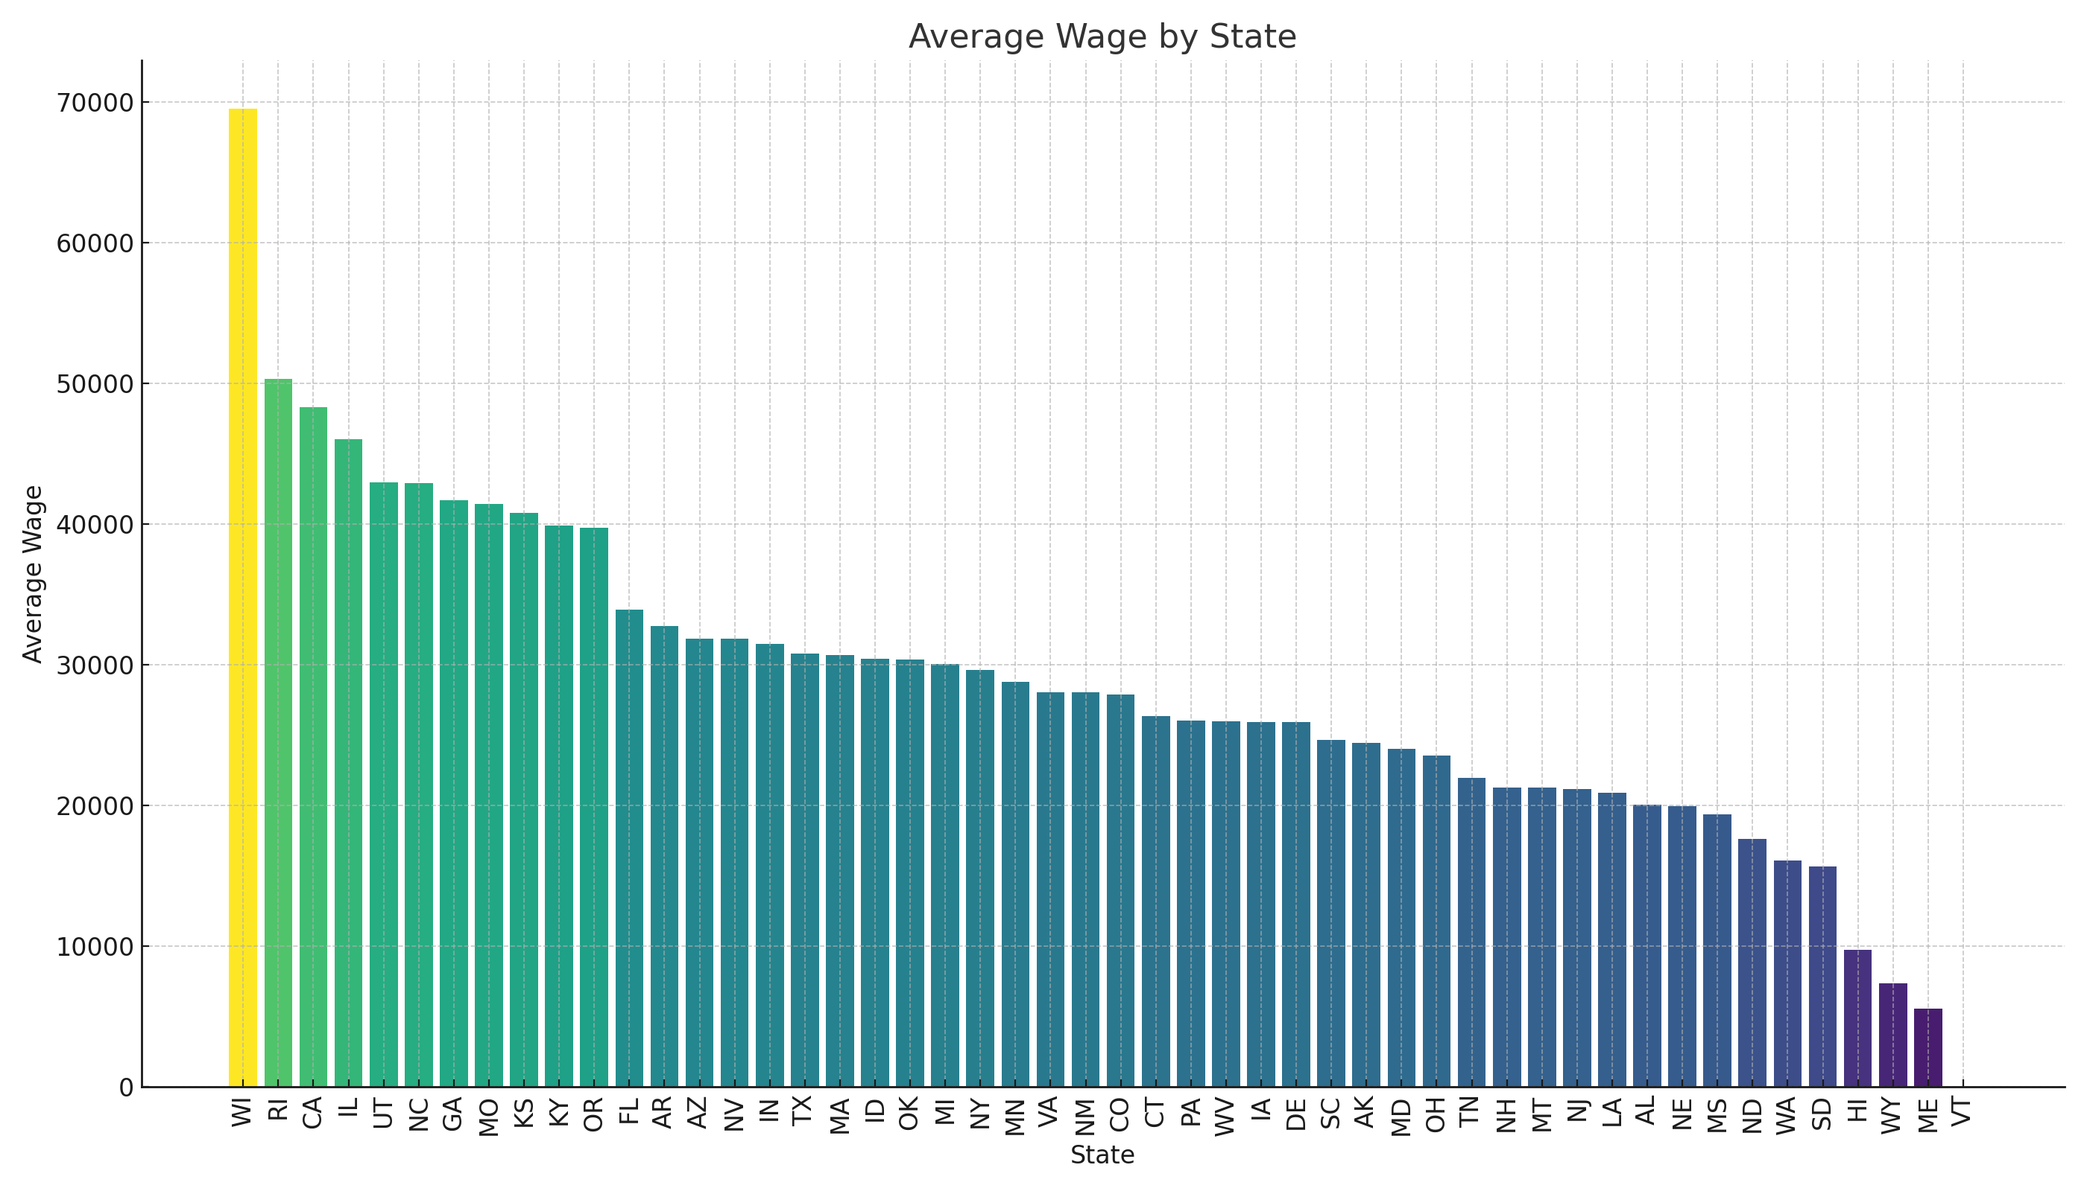

Figure 2: Average Wages by Visa Class
This chart displays the average wages across various visa classes.
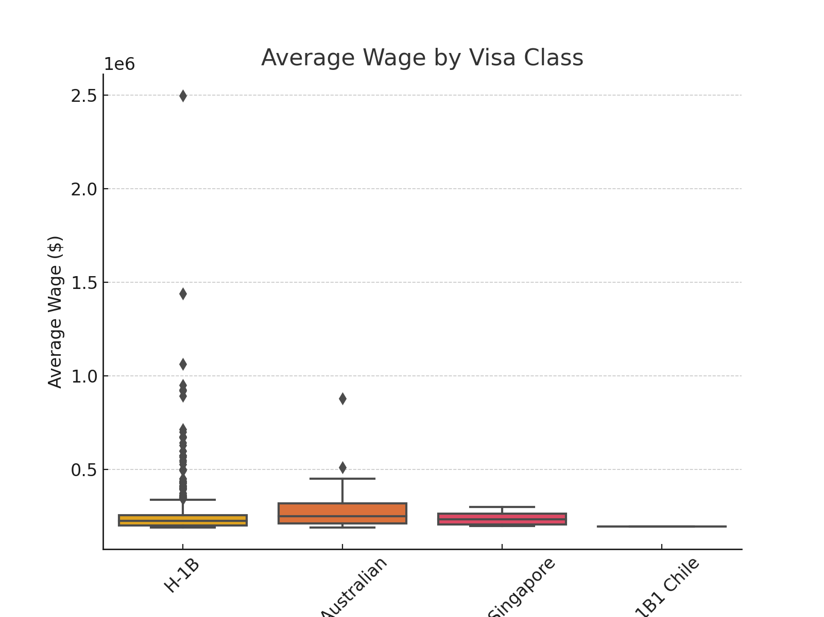

Figure 3: Wage Disparities across states in a table
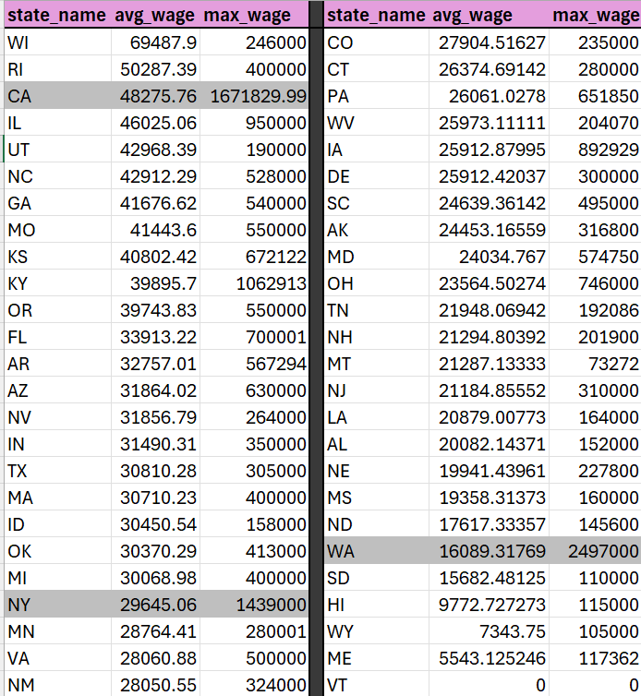

Figure 4: Top 20 Industries by Average Wage
This chart highlights the top 20 industries by average wage.
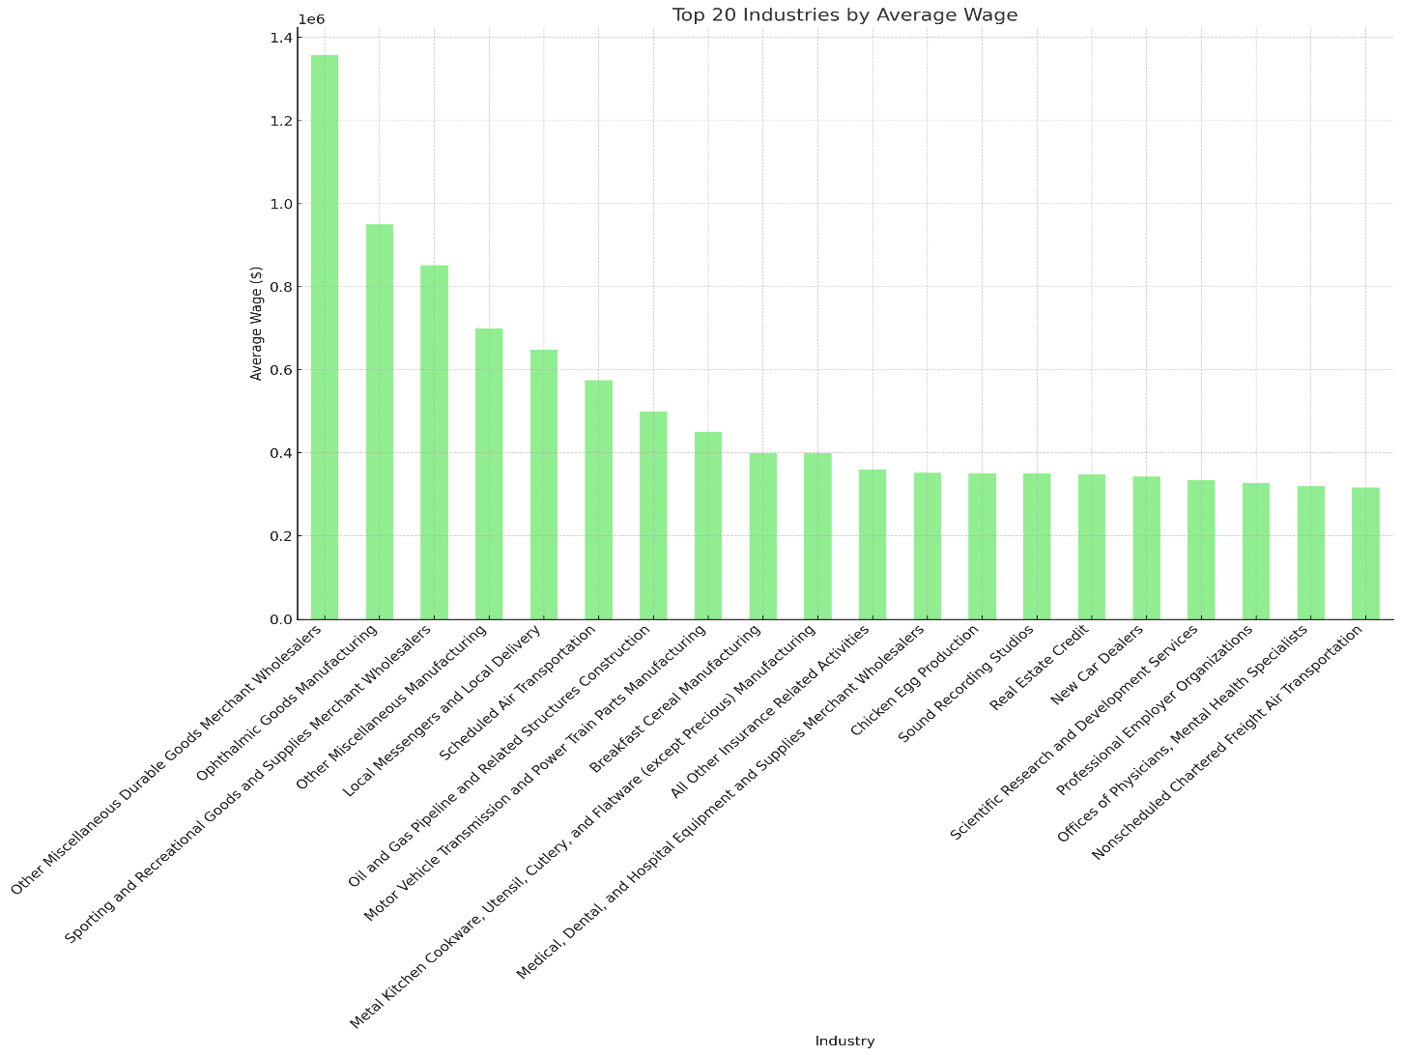

Figure 5: Top 20 Industries by Average Wage
This chart highlights the top 20 industries by average wage.
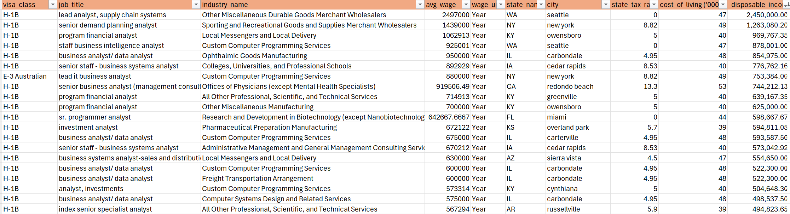

Figure 6: Comparison of Average Wage and Disposable Income Across States (Top 10 by Disposable Income)
